Stalin urges 'Second Front' in 1943

15th March 1943: The prospect of an Anglo-American invasion of Europe in 1943 is now much less likely - leaving Russia to take the brunt of the war
MAR 15

SAVE |  | ▷ LISTEN

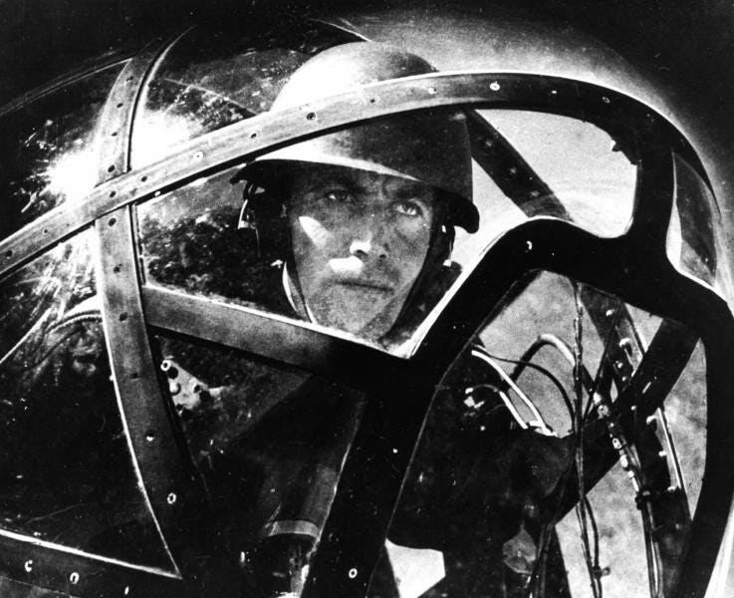
‘Attack’ - a Soviet image from 1943. The Russian forces entered the year in a much better state than they had been since the start of the war - but they knew they faced a long struggle ahead.
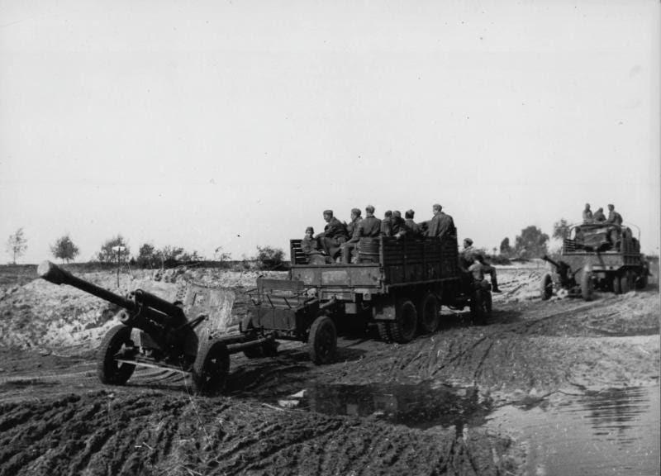
But even as Stalin wrote to Churchill on the 15th March, the Red Army advance following Stalingrad was being broken up by German counterattacks.
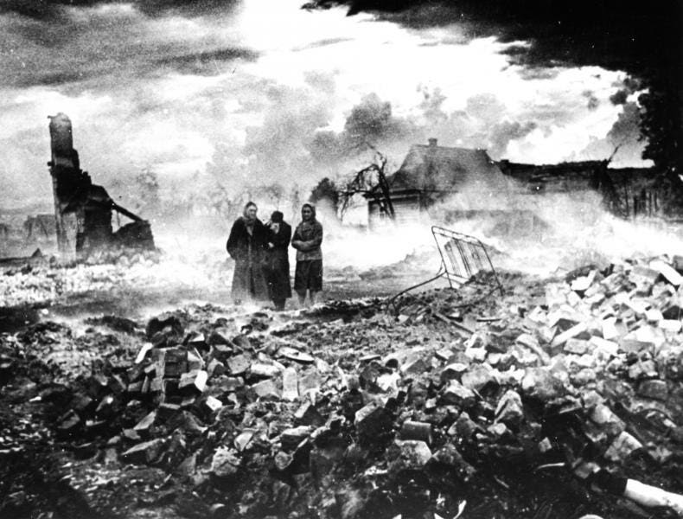
“The enemy has retreated”, 1943. The Soviet state was still pouring all the resources it had into fighting the war, and there was little spare for rebuilding.
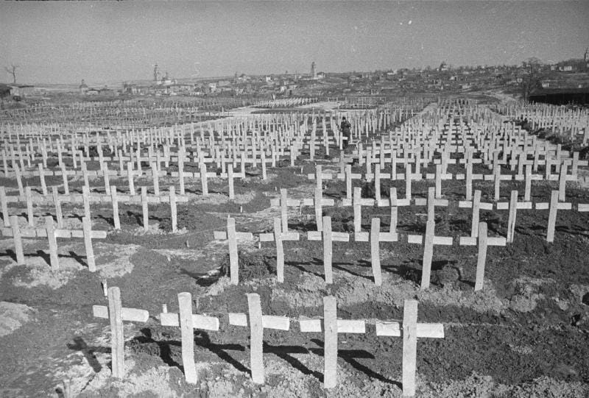
The German sacrifices of 1942 had achieved very little - the German cemetery in the city of Gzhatsk, liberated in February 1943.
On 11th March 1943 Churchill had written to Stalin with a long report on the situation of the British and American forces in the west. They were making progress in Tunisia where they were drawing more and more German troops away from Europe. They intended to move against Sicily next. The bombing war against Germany was being intensified. But there was no prospect of a 'Second Front', an invasion of occupied Europe in 1943.
This is the reason why the uncertainty of your statements concerning the contemplated Anglo- American offensive across the Channel arouses grave anxiety in me, about which I feel I cannot be silent.
The British fear, expressed by Churchill, was that any "premature attack with inferior and insufficient forces" would lead to a "bloody repulse".
The US had at first been enthusiastic for an attack on Europe in 1942. But the more the situation was studied the more it was realised that there were nowhere near enough men in Britain to make such an assault. Nor were any of the other prerequisites for such an operation - such as air superiority, command of the seas and practical matters such as enough landing craft.
Stalin, of course, was not impressed and he wrote to Churchill on 15th March 1943:
Now as before I see the main task in hastening ofthe Second Front in France. As you remember, you admitted the possibility of such a front already in 1942, and in any case not later than the spring of 1943 There were serious reasons for such an admission.
Naturally enough I underlined in my previous message the necessity of the blow from the West not later than the spring or the early summer of this year.
I deem it my duty to warn you in the strongest possible manner how dangerous would be from the view-point of our common cause further delay in the opening of the Second Front in France.
The Soviet troops spent the whole winter in the tense fighting, which continues even now. Hitler is carrying out important measures with a view to replenish and increase his army for the spring and summer operations against the U.S.S.R. In these circumstances it is for us extremely important that the blow from the West should not be put off, that it should be struck in the spring or in the early summer.
I studied your observations, contained in the paragraphs 8, 9, and 10, on the difficulties of the Anglo-American operations in Europe. I recognise these difficulties.
Notwithstanding all that, I deem it my duty to warn you in the strongest possible manner how dangerous would be from the view-point of our common cause further delay in the opening of the Second Front in France.
This is the reason why the uncertainty of your statements concerning the contemplated Anglo- American offensive across the Channel arouses grave anxiety in me, about which I feel I cannot be silent.
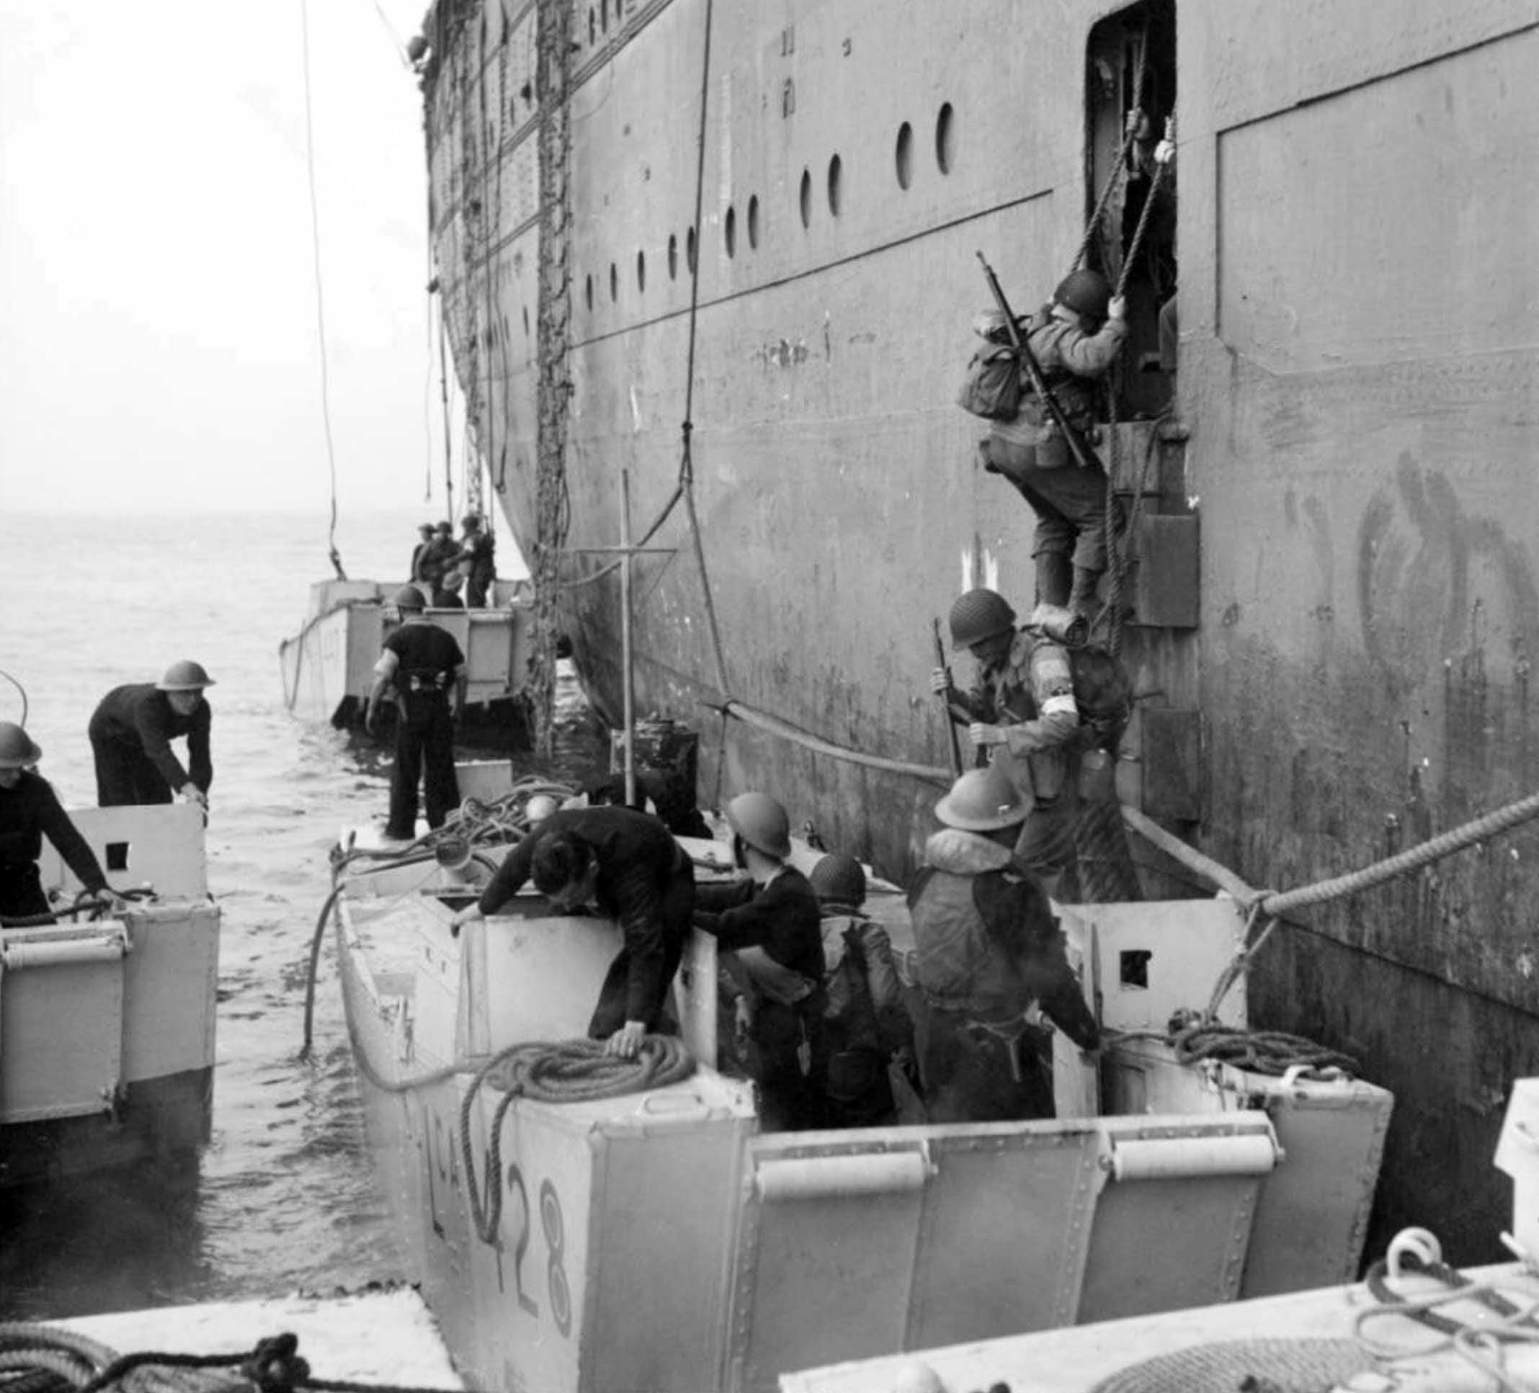
American troops manning their landing craft assault from a doorway in the side of the liner REINA DEL PACIFICO, during the TORCH landings in 1943. the availability of landing craft would become a critical factor in Allied planning for the invasion of Europe
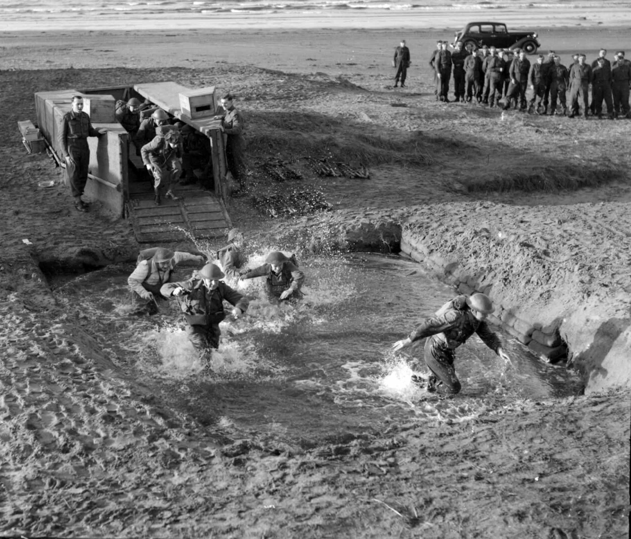
‘Commandos, Britain's shock troops, practising assault tactics at the Combined Operations School at Dundonald Camp. Here they are landing from a dummy landing craft into a shallow pit filled with water so as to simulate a true amphibious landing.’
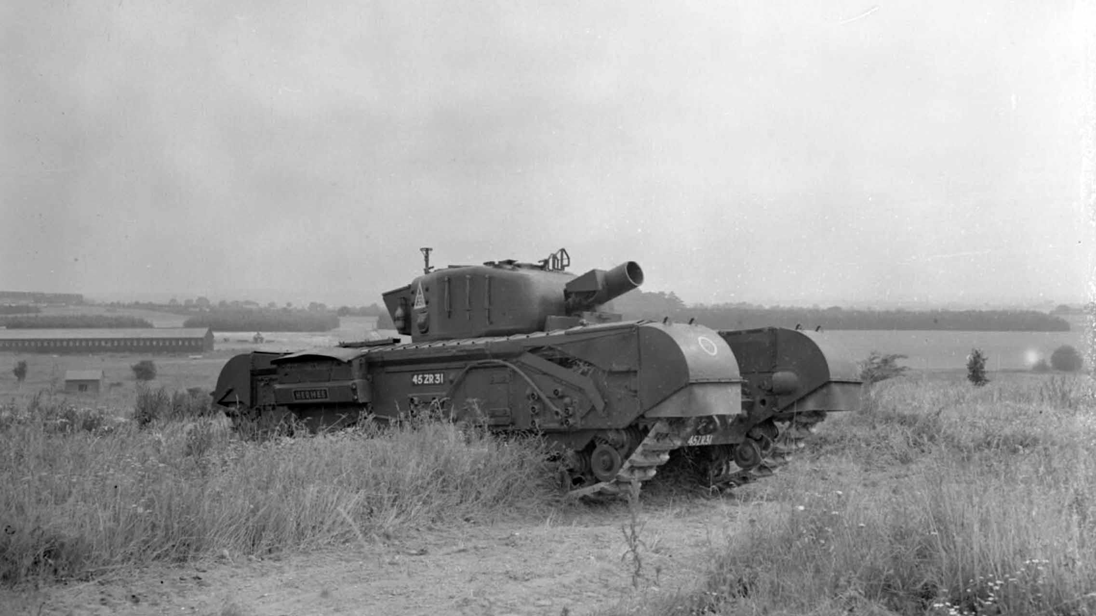
In the wake of the Dieppe disaster, the British were also developing a range of specialist tanks to overcome beach obstacles - including this Churchill AVRE with Spigot Mortar. When D-Day eventually came these would be used, very successfully, to blast apart concrete strong points.

